2017
The Bank of New York Mellon Corporation

Mondal, Md Abdus Samad

[Functional Specification]
[Type the abstract of the document here. The abstract is typically a short summary of the contents of the document. Type the abstract of the document here. The abstract is typically a short summary of the contents of the document.]

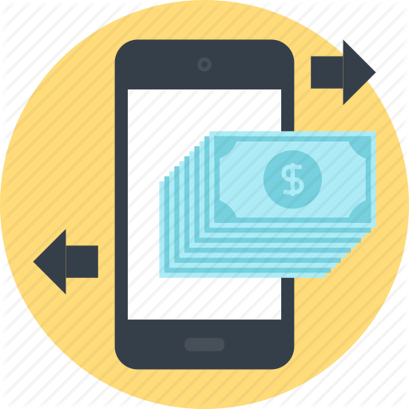
Mobile Banking 1.0
-A.S Mondal

Acknowledgements
The document was completed with thanks to the support from the following individuals and
Companies:
Sl. # | Topic | Name | purpose | Date
1 | Mobile Banking Solution proposal | Venu | Mobile Banking Problem statement and high level overview. | 18-May-2017

Table of Contents
1.INTRODUCTION 3
2.MOBILE BANKING STAKEHOLDERS 3
2.1Bank: 3
2.2 Mobile Network Operator (MNO) 4
2.3 A Mobile Banking Technology Vendor 4
2.4 The consumer 4
3. MOBILE BANKING PLATFORM IMPLEMENTATION OPTIONS 4
3.1. High Level Bank Channel Architecture 4
3.2. Levels of Mobile Banking Platform Implementations 5
3.3. Mobile Banking Platform High Level Architecture 6
4.Mobile Banking Bearer Technology Options 8
4.1 Server-Side Technologies 8
4.2 Client-Side Technologies 8
5. SMS Banking Solution 8
6. Interactive Voice Response (IVR) 9
7. Unstructured Supplementary Service Data (USSD) 9
8. Wireless Application Protocol (WAP) 10
9. JAVA/J2ME 11
10.SIM Based Applications 11

1.INTRODUCTION
Bank of Tritech is one of the largest Public Sector Banks in India and has international operations in 25 other countries. In India, the Bank consists of a branch network of 5000+ branches and 7500+ ATM’s. Bank of Tritech is known as India’s International Bank and has a reputation of being at the forefront in the usage of technology. While Bank has a vast network of Branches, Bank’s operations are fully automated and the customers of the Bank avail of various alternate channels of delivery.

Bank of Tritech, hereinafter referred to as the Bank has decided to automate regular banking operations in order to provide better experience to the customers. As part of this plan, Bank proposes to implement mobile banking solution, on CAPEX basis, to offer an innovative offering to attract the customers for continual usage of banking services through mobile handset. The proposed solution will be hosted in Banks Data Centre (DC) with Disaster Recovery (DR) site.

2.MOBILE BANKING STAKEHOLDERS
The delivery of a mobile banking service to a consumer involves the participation of four primary
players;
  - A Bank,
  - Mobile Network Operator (MNO),
  - A Mobile Banking Technology Vendor, and
  - The consumer.

2.1Bank:
The bank typically has a multi-channel approach to delivering transactional services to its customer base. Its channels include the traditional bricks and mortar branch, ATMs, POS and the internet. These channels have gone a long way in servicing the retail banks in delivering financial transaction volumes and assisting in extending the banks reach to its customers. These channels come at a cost of infrastructure and implementation and can typically serve developed markets, or developing market urban and semi-urban areas where population density and the availability of infrastructure is readily available.
Under this category the stakeholders are –
A. Bank customers
B. Bank Administrator
C. Bank Manager
D. Data Manager

2.2 Mobile Network Operator (MNO)
MNO provide the infrastructure to run the mobile banking platform.

2.3 A Mobile Banking Technology Vendor
The companies who develop the mobile banking application manage and maintain the mobile banking application in the MNO infrastructure.
Banks can develop their own applications in-house, in which case the IT department would be classified
as the ‘vendor’.

2.4 The consumer
The consumer is basically the bank customers who actually use the mobile banking application.

3. MOBILE BANKING PLATFORM IMPLEMENTATION OPTIONS

3.1. High Level Bank Channel Architecture

Mobile banking is seen to be an extension of the existing payment infrastructure of a bank to mobile phones as a channel for the leveraging of the mobile network and its reach, to deliver banking services to consumers.

The mobile banking infrastructure thus sits in a similar technical environment to the banks ATMs, POS, branch and internet banking service offerings.

A bank’s core banking system, the system that houses the consumer’s account and related transaction management and history, would require a means to translate banking instructions, received from consumers, through one of the bank channels such as ATMs or the internet, into a format that the core banking system can process. This translation is normally performed by an EFT channel switch-1.The EFT channel switch would switch transactions from the channel to the appropriate area within the core banking system.

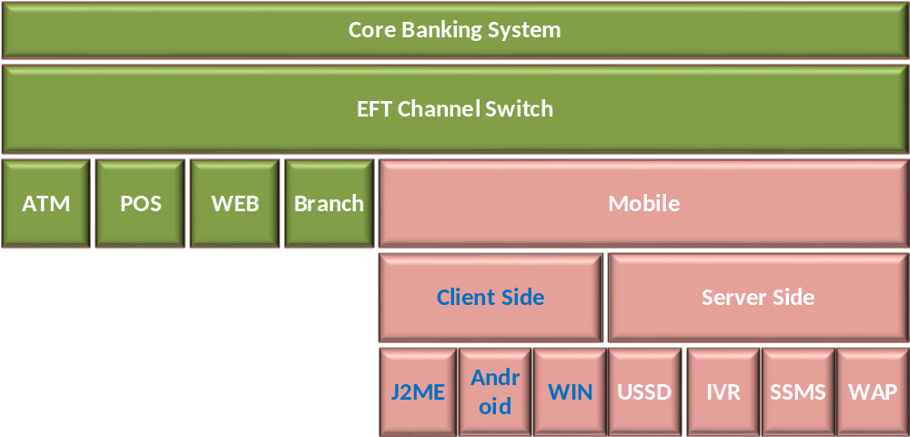
Figure 1: Mobile Banking in the overall banking architecture.
1.An Electronic Funds Transfer, EFT, or Financial Switch accepts, translates and forwards transactions
from multiple channels to the bank’s core systems. This can sit within the bank or the bank’s third party
processor. 2.Access channel for a consumer from their mobile phone, such as SSMS, WAP, USSD2, etc.
The mobile banking channel can be delivered to the consumer through two bearer or application environments.
Client-side applications are applications that reside on the consumers SIM card or on their actual
mobile phone device. Client-side technologies include J2ME and Android. Server-side applications are developed on a server away from the consumer mobile phone or SIM card. Server-side technologies include USSD2, IVR, SSMS and WAP. The bank would only need to select one of these bearer13 channels, or bearer channel strategies,
for implementation. However, in some markets it would be wise to implement more than one bearer channel in order to manage consumer take up and the risk associated with non-take up of a specific technology. The selected bearer channel does not have an effect on where the mobile banking platform should sit.

3.2. Levels of Mobile Banking Platform Implementations
The extension of the payment franchise to mobile can be as simple as a bank channelenablement or as complex as a complete bank system implementation depending on what infrastructure already exists, and that which can be re-used as part of the implementation.

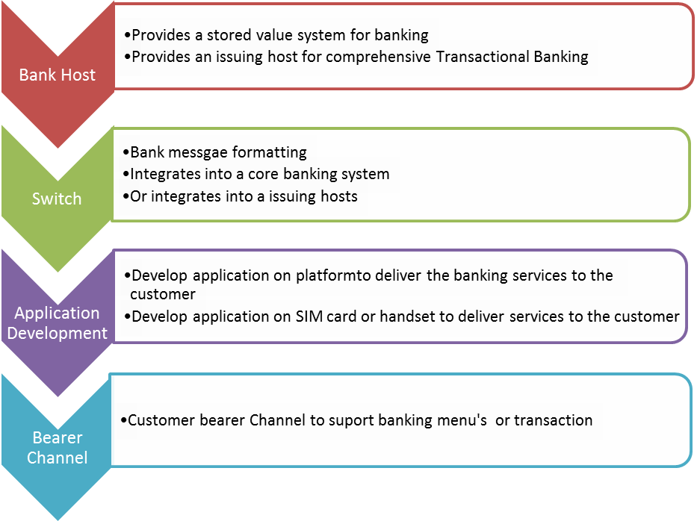

3.3. Mobile Banking Platform High Level Architecture
If we look at a typical bank as one that already has a core banking system, then the mobile
banking platform that the bank would use, or integrate with, would have the following
components:

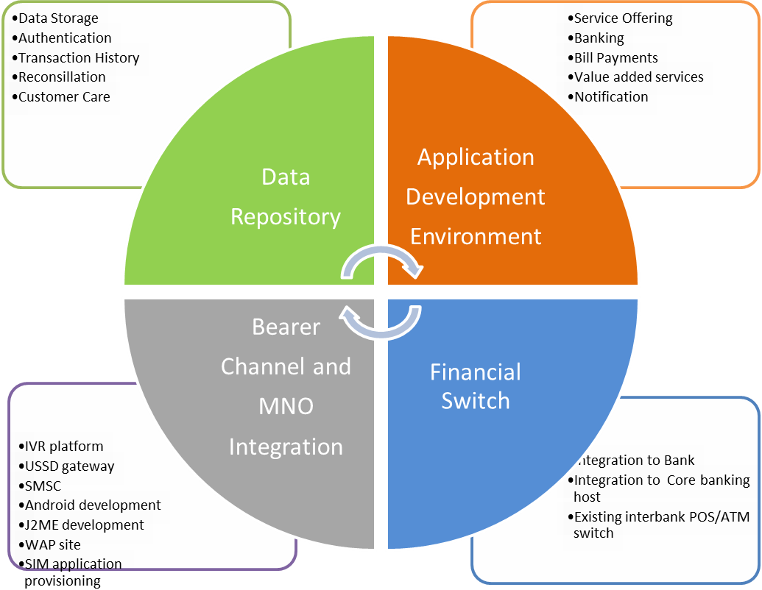
Fig 3. Components of a Mobile Banking Platform

The diagram above reflects a typical mobile banking service. The service would require integration into an MNO to facilitate the usage of the network’s bearer channels and in order to access the consumer’s mobile phone.
The Data Repository stores enough customer information, to facilitate the processing of
financial transactions. The data repository would also house sufficient information to authenticate the customer in each transaction. By housing transactional and consumer data, the repository would also facilitate customer care, and the reconciliation of certain financial transactions that use the application development environment to fulfil services. E.g. selling airtime would require reconciliation between the transactions processed and the airtime loaded
by the network operator.The Application Development Environment facilitates the actual service development to the
consumer, such as banking menus and commands. It may house the integration of third parties in supporting value added services such as bill payments or airtime sales. The application development environment fosters the intelligence delivered to the consumers handset, whether client or server side.

The Financial Switch would act as the interface to the bank’s core banking system. Instructions
collected by the application development environment through the MNO interface, and using data
from the data repository, are translated through the financial switch into a transaction format that the
bank can use.

4.Mobile Banking Bearer Technology Options
This section addresses the front-end component or consumer-facing Mobile Banking Technologies. This component of the end-to-end mobile banking value chain is typically supplied or customised by either a mobile banking vendor or the specialised technology unit within a bank.
These Mobile Banking Technologies can be categorised into two environments:

4.1 Server-Side Technologies
Server-side technologies are those applications built on a server, away from the consumer’s SIM or Mobile handset. Examples of server-side technologies would be SMS, IVR, USSD2 and WAP.

4.2 Client-Side Technologies
Client-side technologies are those applications, solutions and service offerings built or embedded on a consumer SIM or mobile handset. Examples of client-side applications are S@T and J2ME (JAVA).
These consumer-facing technologies each have differing characteristics and processes. Each of these technologies requires that the consumer register or activate the application with the bank/MNO/vendor offering the service in the market. This registration process is defined by the service provider and serves as an initial identification
of the consumer to ensure ongoing trust in, and security of, the transaction. There are numerous methods of registering or activating customers in existence, all of which require the endorsement of the bank offering the service.
Consumer registration often creates a barrier to consumer adoption, but serves as a necessary step in the process of eliminating fraud and potential transactional risk in the offering (as well as being a regulatory requirement).
In server-side applications, consumer data that enables the processing of transactions, such as account/card details, are typically stored in a secured environment, on a server at a bank or at their allocated service provider/vendor.

In client-side applications, the consumer data is typically stored on the application, or entered by the consumer, and encrypted by the application in the SIM or handset. Each of the server-side and client-side applications are briefly described below.

5. SMS Banking Solution
SMS (Short Messaging Service) allows users to send and receive text messages on a mobile phone using the numbered keypad on the handset to input characters. Each message can be up to 160 characters long and sent to and from users of different operator networks. All mobile phones available today support SMS. Indeed, SMS has become a global phenomenon, with billions of text messages sent worldwide every week. It is estimated that a worldwide total of 1 trillion text messages were sent in 2005. In addition to the person-to-person SMS, a large variety of content-based text messaging services are available. The majority of GSM operators offer users the ability to subscribe to
services that send news, sport and entertainment content direct to a mobile phone in the form of an SMS.14
SMS Banking requires a registered customer to initiate a transaction by sending a structured SMS (SSMS) message to the Mobile Banking Service. This SSMS requires a tag word identifier to instruct the SMS gateway to submit the message to the correct SMS application. A tag word is the first word in the SSMS. The balance of the SSMS would hold the instruction from the customer to the Mobile Banking application.
E.g.: ‘bank_balance_PIN’ for a sms based bank balance enquiry;
or
bank_transfer_cheque_savings_100.00_PIN’ for a transfer from a cheque account to a savings
account of an amount of 100.00.

In each of these examples the SSMS would be sent to a SMS short code or address (a shorter version of a phone number). The SSMS would pass from the consumer’s handset through the GSM Network to the MNO SMSC (Short Message Service Centre). A SMSC stores and forwards the SSMS to the SMS Gateway allocated to the short code used by the Mobile Banking Service Provider. The Mobile Banking Service Provider would use the consumer’s mobile number, forwarded by the SMSC with the SSMS, to identify the consumer and respond to the consumer’s request.
The response would follow the same return path and, in the examples given above, would respond to the consumer with an SMS confirmation message. E.g. ‘Bank Balance 150.00’ or ‘Transfer from cheque to savings of 100.00 successful’.

6. Interactive Voice Response (IVR)
In telephony, interactive voice response, or IVR, is a phone technology that allows a person, typically a telephone caller, to select options from a voice menu and interact with the phone system. A pre-recorded voice prompt is played and the caller presses a number on a telephone keypad to select an option, i.e. "press 1 for yes, press 2 for no". Speech recognition can also interpret the caller's simple spoken answer such as "yes", "no", or more complex words, sentences and business names, or a number as a valid response to the voice prompt. DTMF signals (entered from the telephone keypad) and natural language speech recognition interpret the caller's response to voice prompts.15 IVR is the oldest form of consumer-facing mobile banking technology. IVR has been used prior to the existence of mobile phones in the form of telephone banking and is still in use today. IVR requires a registered consumer to make a call to a published telephone number and be answered by a pre-recorded voice that presents various menu options to the consumer. The IVR system would then take the necessary instructions from the consumer by recording the tones of the number selections that the consumer enters on the key pad, or through spoken commands, and creates an instruction that is given to the service provider/bank. The service provider would use the consumer’s mobile number forwarded by the network operator to identify the consumer and as a factor of authentication.

The channel can be used by any mobile device and any consumer capable of making a call. The service provider is required to have an IVR system which can cost as little as US$7000.00 However, it can also scale up to be fairly expensive depending on the number of customers that need to be served. IVR systems are user friendly but may

14 www.gsmworld.com

prove expensive to maintain and expensive to the consumer who needs to make what can be a relatively lengthy call. Of course, this is dependent on who pays, depending on whether it is a free phone number or not.

7. Unstructured Supplementary Service Data (USSD)
In its simplest definition, USSD is a menu driven form of SMS where a customer would receive a
text menu on their phone as opposed to a string of words.
USSD is a data bearer channel in the GSM network. Like SMS, it transports small messages of up
to 160 characters between the mobile handset and the network. Unlike SMS, which is ‘store and
forward’, USSD is session based and can provide an interactive dialog between the user and a
certain set of applications. In other words, both sides of the dialogue happen during a session
whereas an SMS based interaction is broken into each segment of communication between the
client and the service.
USSD1 only allows one way communication to the network, USSD2 allows two way
communications between the user and the network. With USSD1, the interaction between the
user and the service would be broken into each communication segment, much like SMS. With
USSD2 it would be held in the same session and allow for a flowing conversation between the
user and the service. This is similar to e-mail and instant messaging, e-mail waits for the
recipient to read and respond while as instant messaging allows for immediate dialogue. USSD is
as standard a feature as SMS and is available in an estimated 95% of handsets today16.
USSD requires no pre-configuration on the consumers SIM or handset and is already built into
most GSM networks. MNOs do, however, need to commercialise the product by establishing the
necessary bearer channel billing capability, and promoting the use of USSD for value added
services in addition to internal network and customer care use. E.g. from *100# which would
deliver an SMS balance of your prepaid airtime account to a more intuitive full service menu as
discussed below.17
A registered consumer would dial a number that includes *s and #s. This number could be
saved in the consumer’s phone book as the bank’s name to avoid confusion in dialling or having
to remember the USSD string.
An example of a USSD string would be *120*2265#. 2265 spells bank and therefore could be marketed as *120*bank#.18

Once the consumer has entered, and dialled the USSD string, the consumer’s request for the service would be passed through the network to the USSD gateway at the MNO, which in turn would recognise who the service provider/bank was and forward the request to that service provider.19

The service provider would respond by forwarding to the consumer, through the MNO, a text based menu similar to the one on the left. The consumer would receive this menu on their screen, press the reply button on their phone
and enter the number of the option that they required. Example: Press reply, enter 1. To which the service provider would collect the balance information for the consumer and send back a message that says:
The Balance of your account is 100.00.

8. Wireless Application Protocol (WAP)
WAP is best described as the internet on a mobile phone. WAP is an open international standard for applications that use wireless communication. Its
principal application is to enable access to the Internet from a mobile phone or PDA.
A WAP browser provides all of the basic services of a computer based web browser but is
simplified to operate within the restrictions of a mobile phone. WAP is now the protocol used for
the majority of the world's mobile internet sites, known as WAP sites.
Mobile internet sites, or WAP sites, are websites written in, or dynamically converted to, WML
(Wireless Mark-up Language) and accessed via the WAP browser.20
WAP or mobile internet banking offers a consumer a similar experience to that of internet
banking.
The consumer would browse to a mobile internet site by accessing the WAP browser on their
mobile phone and entering the website address. The actual banking application
resides at the bank and is secured
and monitored in the same way as
an internet banking website.
The mobile phone and bearer
(GPRS) is used to display or
transmit the data between the
consumer and the bank.
A consumer’s handset would need
to be capable (functionality
developed/loaded by the handset
manufacturer), and have the right configuration (provided by the MNO), in order to support
WAP Banking.
MNOs often segment this functionality to post-paid customers only.

9. JAVA/J2ME
J2ME (Java 2 Micro Edition) is a feature that allows the device to run small, user-installable
software applications written especially for mobile devices such as phones.21
J2ME requires a phone that can support the GPRS download of the initial application, assuming
the phone is not pre-provisioned with the application.
The phone would have to also have enough memory capability to support or house the
application, and sufficient graphic ability to display the application.
Once installed on the phone, the application would use GPRS, USSD or SMS to carry the
consumer data or instruction from the device to the service provider. This can be in an
encrypted format.
The J2ME environment can be MNO agnostic in that the application can be downloaded and
used across any MNO that supports mobile internet.
The user experience is similar to that of a web site and brings the same content and graphic rich
benefits of the internet to the mobile phone. But the application can impact the consumer in the
initial download process due to their phone not being provisioned properly by the handset
manufacturer or their GPRS capability not being enabled at the network.
These barriers affect all client-side applications.
A consumer would browse through his phone menu until they find the J2ME application, select
and launch the application, and follow the JAVA browser menus to complete a transaction.
The data is typically encrypted prior to leaving the handset and being sent to the service
provider or bank. Once received, the service provider or bank would decrypt the message and
process the consumer’s instruction.
J2ME applications can be pushed to the mobile phone by a service provider22 or downloaded by
a consumer by accessing the service provider’s mobile internet site.

10.SIM Based Applications
The SIM Application Toolkit (SAT/S@T) allows for the service provider or bank to house the
consumer’s mobile banking menu within the SIM card.
The SIM Application Toolkit (commonly referred to as STK) is a standard of the GSM system
which enables the SIM to initiate actions which can be used for various value added services.
The SIM Application Toolkit consists of a set of commands programmed into the SIM card which
define how the SIM should interact directly with the outside world and initiates commands
independently of the handset and the network. This enables the SIM to build up an interactive
exchange between a network application and the end user, and access or control access to the
network. The SIM also gives commands to the handset, such as ‘display menu’ and ‘ask for user
input’.
STK has been deployed by many mobile operators around the world for many applications,
where a menu-based approach is required, such as mobile banking and content browsing.23
The challenge in SIM based applications is getting the application onto a SIM card that already
exists in the market.
The service provider has the option of sending the application Over The Air (OTA), which entails
the delivery of several encrypted SMS messages that self-configure the application on the SIM,
or, provisioning a new SIM card with the application already embedded within the SIM.
The latter has an economic impact on the network operator and the existing consumer in that
the consumer would have to obtain a new SIM card in order to use the application.
Once the application is on the SIM, instructions from the consumer can be entered, encrypted,
and transported by SMS to the service provider or bank.
There may be difficulty in upgrading or making changes to the application on the SIM as the
consumer would have to re-provision the application in a process similar to that described above; or the network operator would have to re-load the application over the air to each and
every SIM card each time they make a change to the application.
A benefit of SIM Based Applications is the ability of the network operator or bank to own a piece
of the real estate on the SIM Card. Since the SIM card is provided by a specific MNO, this
ensures the prevention of churn for that MNO, and ensures that the bank’s specific application
is on the SIM and therefore provides similar benefits to the bank.

11. Android Based Applications
Android mobile OS based application is a feature that allows the device to run small, user-installable
software applications written especially for mobile devices such as phones.21
Android requires a phone that can support the GPRS download of the initial application, assuming
the phone is not pre-provisioned with the application.
The phone would have to also have enough memory capability to support or house the
application, and sufficient graphic ability to display the application.
Once installed on the phone, the application would use GPRS, USSD or message to carry the
consumer data or instruction from the device to the service provider. This can be in an
encrypted format.
The Android environment can be MNO agnostic in that the application can be downloaded and
used across any MNO that supports mobile internet.
The user experience is similar to that of a web site and brings the same content and graphic rich
benefits of the internet to the mobile phone. But the application can impact the consumer in the
initial download process due to their phone not being provisioned properly by the handset
manufacturer or their GPRS capability not being enabled at the network.
These barriers affect all client-side applications.
A consumer would browse through his phone menu until they find the Android application, select
and launch the application, and follow the JAVA browser menus to complete a transaction.
The data is typically encrypted prior to leaving the handset and being sent to the service
provider or bank. Once received, the service provider or bank would decrypt the message and
process the consumer’s instruction.
Android applications can be pushed to the mobile phone by a service provider22 or downloaded by
a consumer by accessing the service provider’s mobile internet site.

12. Devise Support
The application must support and run in standard mobile handset/Tab run on android/windows/j2me/web.It also support the different handset launching in the market.

13. Policy and Regulatory
Mobile banking application must conform to all the operational security guidelines prescribed by the Regulatory /Statutory bodies such as RBI, TRAI, and NPCI etc. which come into force from time to time.
The solution offered should comply with all the Operative Guidelines for Mobile Banking Transactions in India issued by RBI vide circulars no.DPSS.CO.No.619/02.23.02/2008-09 dated 08/10/2008, DPSS.CO.No.2502/02-23/02/2010-11 dated 04/05/2011, DPSS.CO.PD.MobileBanking. No/02.23.001/2013-14 dated 01/07/2013 & Appendix and DPSS.CO.PDNo.1098/02.23.02/2011-12 dated 22/12/2011, RBI/2014-15/337DPSS.CO.PD.No.1017/02.23.001/2014-2015 dated 04/12/2014, RBI/2014-15/104 DPSS.CO.PD. Mobile Banking. No. 2/02.23.001/2014-15 dated 01.07.2014, RBI/2013-14/116 DPSS.CO.PD.MobileBanking.No./02.23.001/2013-14 dated 01.07.2013 and Report of the Technical Committee on Mobile Banking dated 07/02/2014, Report Customizing Mobile Banking in India : Issues and Challenges by Harun R. Khan dated 11.10.2012& 05.09.2012, M-Banking in India - Regulations and Rationale by K. C. Chakrabarty dated 09/04/2012& 29/03/2012. The solution should also comply with any further guidelines and mandates issued by RBI for Mobile Banking Transactions. The CompanyX has to undertake to incorporate, at no cost to the Bank, suitable changes in the solution including the software, procedure and operations as required from time to time to comply with any new rules of Indian Law from RBI/IBA/MFI/TRAI/Govt. of India/NPCI and other Regulators for providing the Mobile Banking services.

14. Installation, support and user manual document
The vendor company developing the platform will be responsible for supply, installation and end to end implementation of Mobile Banking Solution, including customization, training to bank officials, etc. The training and support manual should be delivered as user manual/kit, maintenance user manual, technical documentation as hard(printed copy) and soft copy in PDF format. The documentation should include details regarding application architecture, database, network infrastructure requirements, and back-up and disaster recovery plan. All the manuals shall be in English and the documentations should be clearly indicative of the overall solution with architecture diagram.

15.Operational Failure and recovery
The solution should be designed with redundancy in mind to ensure nil impact by failure of one or more components / servers or software.

16. Maintenance and troubleshooting
The CompanyX has to provide support for troubleshooting and enhancements in the services during the contract period. Enhancement would include inclusion of all new browser/handset/ devices/mobile platform OS coming in the market within 1 month of their launch and also new market/industry related functionalities.

16.Recovery and Resiliency
The required hardware and infrastructure would be installed at banks datacenter (DC and DR locations along with auto/manual synchronization). The solution should be configured with automatic replication to DR site with Recovery point objective (RPO) and Recovery time objective (RTO) as specified by the Bank’s policy, currently it is RPO for CBS interfaced application is 10 minutes and RTO is 2 hours. The selected CompanyX has to ensure flawless switching of all the services under purview of this RFP to Disaster Recovery (DR) site during DR drill as and when decided by Bank or in case of non- availability of primary DC site.

